Origins of the Trombone:
Evolved from the trumpet – slide trumpet – renaissance slide trumpet, had a telescopic slide that was capable of playing the same notes of about four adjacent harmonic series. (1450 – 1600)
The double “u” shaped slide led to the fundamental features found on a modern day trombone. This was a very sophisticated piece of engineering that developed in the mid-fifteenth century compared to other instruments of it’s time given the limitations of metallurgy at that time.
It was then theoretically possible for a skilled trombonist to play semi tones between the highest and lowest points of a wide melodic scale.
The trombone was then quickly adopted and integrated into major cultural centres of Europe. Within a short time, trombone players became the most celebrated musical practitioners – skills were prized in cities courts and cathedrals and they flourished in the tonal and ambient world of the Renaissance. The slide provided remarkable facility and tonal expansion to western music.
Modern reproductions can be blown loudly to sound like a trumpet and also tempered in color to sound relatively modern.
Research suggests that early Renaissance trombonists articulated in such a way that mimed the vocal enunciation of singers during that time.
It is important to remember that there was very little labeling of instrumentation (of any kind) before the second half of the 16th century. This is not surprising as most early trumpet and trombone players did not play from written music, or learn in a system in which notated music was central. Musical instincts and virtuosity prevailed during this very special time in early brass history. Musical literacy was less of a marketable skill than was the simple mastery of range, color, improvisation and technique for that time. The early gig was not unlike playing tunes and improvisation in a small jazz combo today.
Make no mistake – the instruments and musicians of this early period were part of a well established and thriving musical scene and trombonists were well respected and prominent during that culture – just like today!
Early trumpets – to be sure – had existed in the most ancient of civilizations and served in utilitarian and military capacitates. As a result, the signal of power, formal authority and civic function had been ascribed to the trumpet player since biblical times. The formation of guilds, apprenticeships, and social hierarchy established the trumpeter in fraternities and dynasties. These devices existed to protect standards (early union standards).
Paintings and notes of the early fifteenth century dance band with articulated “S” curved slide trumpets are found by Geertgen tot St Jans “The Glorification of Mary” (1490) and the “teasing the dog” pictograph by Mittelalterliches Hausbauch.

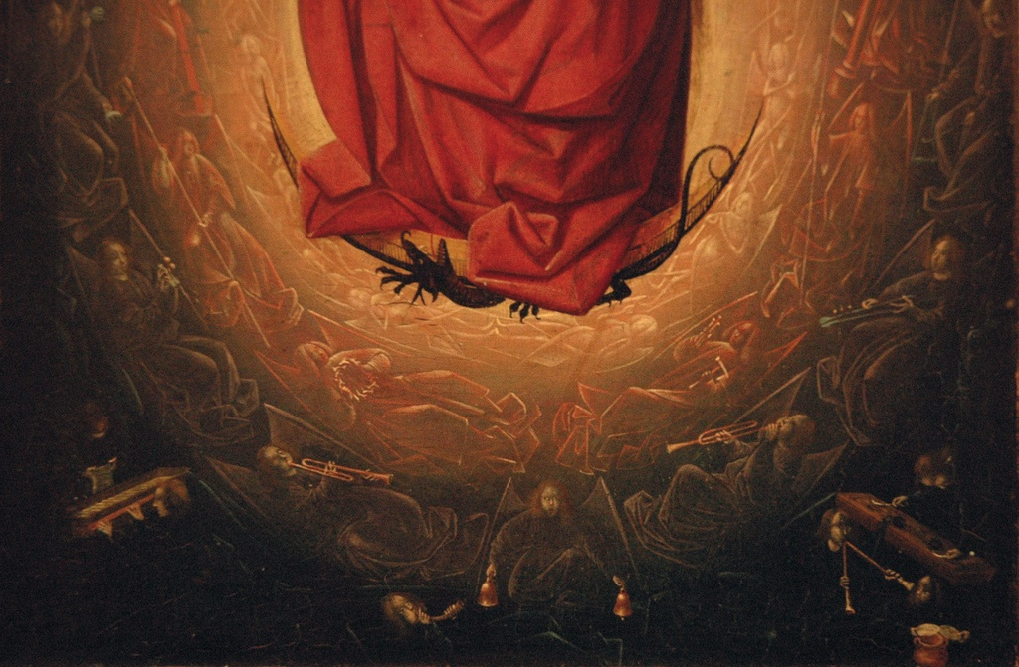

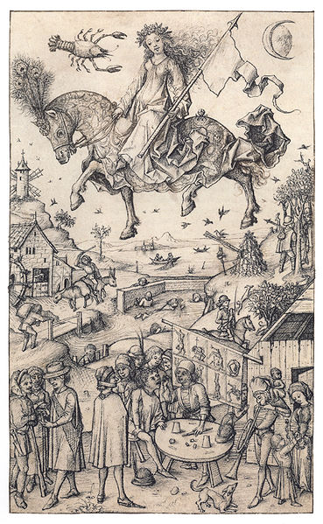
Mittelalterliches Hausbuch (late 15th century)

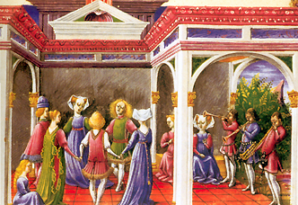
Taddeo Crivelli, round dance with the alta band – minstrel trumpets with slide mechanism in parallel.
Early Trombone Concepts (Renaissance) of style, tone, blend and technique:
It is important to understand that the orbit of players during this genre revolved around networks that were fundamentally influenced by the infrastructure of European patronage (similar to today). The loyalties of players were negotiable and players moved from place to place in search of better employment and pay. The best players were celebrated and sought after. The three principal sources of employment were aristocratic courts, civic authorities and the church (unlike today – this is a dying culture). Court and town band players often supplemented the music at the cathedrals, and also played for processions and theatrical events. Players had to be diverse in their skills and this was reflected in their employment opportunities. As the sixteenth century progressed, players began to show loyalty to a single employer and often aligned themselves with a Koppel miester and organist. Music was not diversionary or an opiate but rather a function of everyday life and liturgy. The secular realm of town bands and court work created a vibrant culture and tapestry of music throughout Europe during this period. Today, free lance players are more likely to be involved in show, theatre, orchestral, teaching and occasional chamber work with church work detailing only a small percentage of income (unless you live in Waco). The cathedrals of today serve more as a venue than a weekly routine of playing and income. Minstrel Schools served as the higher ed of sacred musical study and trained musicians in feasts, communal worship, musical performances of sacred masses.
The trombonists of these schools were adept in areas of ornamentation and flourished within the confines of a fluid instrumentation. Trombones of this period did not merely supplement SATB but rather served as the descant, polyphony and interlude. As a result, the texture and color of the trombone section was much less homogeneous and more about three or four separate colors. Note length and articulations were most obviously similar however attention was most likely given to an individual color within the section.

